|  |  |  |  |
| --- | --- | --- | --- |
|  | **Bansilal Ramnath Agarwal Charitable Trust's**  **Vishwakarma Institute of Information Technology**  **Department of**  **Artificial Intelligence and Data Science** | | |
| Student Name: Siddhesh Dilip Khairnar | | | |
| Class: T.Y. | Division: B | | Roll No: 372028 |
| Semester: V | | Academic Year: 2023 - 24 | |
| Subject Name & Code: Cloud Computing and DevOps: ADUA31203 | | | |
| Title of Assignment: Linux commands practice | | | |
| Date of Performance: 16/08/2023 | | Date of Submission: 20/08/2023 | |

**Assignment: 1**

1. mkdir (Make Directory): This command is used to create new directories. You provide the name of the directory you want to create as an argument.

1. cd (Change Directory): This command is used to change the current working directory. You can use it to navigate through the file system and move into different directories.

1. echo: The `echo` command is used to display a line of text or output to the terminal. It takes the text or string provided as an argument and prints it to the standard output. This command is often used for displaying messages, variables, or other textual information on the screen. It's a simple way to provide information or feedback to the user when running scripts or interacting with the command-line interface.



1. ls (List): The `ls` command is used to list the contents of a directory. It shows you the names of files and subdirectories within the specified directory.

1. more: The `more` command is used to display the contents of a text file in a paginated manner. It allows you to view a file one screenful at a time.



1. cp (Copy): The `cp` command is used to copy files or directories from one location to another. It creates a duplicate of the specified file or directory.



1. mv (Move): The `mv` command is used to move files or directories from one location to another. It's also used to rename files and directories.



1. grep: The `grep` command is used to search for specific patterns (text strings or regular expressions) within files. It's often used to find occurrences of a particular word or phrase.



1. mv (Move): The `mv` command is used to move files or directories from one location to another. It's also used to rename files and directories.



1. rm (Remove): The `rm` command is used to delete files and directories. Be cautious when using this command, as deleted data is typically not recoverable.

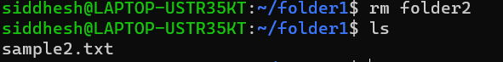

1. find: The `find` command is used to search for files and directories in a specified location and perform actions on them based on conditions you specify.



1. pwd (Print Working Directory): This command displays the full path of the current working directory, showing you where you are in the file system.

1. tar: The `tar` command is used to create and manipulate archive files. It can compress multiple files and directories into a single archive file, making it easier to transport or share them.

1. rmdir: The rmdir command is used to remove empty directories from a system. The directory must be empty, and you must have written permission in its parent directory. The syntax for the rmdir command is rmdir <dirname>.

1. touch: The touch command in Linux is used to create, change and modify timestamps of a file. It is a standard command used in UNIX/Linux operating system.

1. cat: The cat command is a command-line utility for displaying, concatenating, writing to, or appending files. It is a very versatile command with many uses.

1. head: The head command in Linux prints the first lines of a file or input stream. It is often used to troubleshoot problems by quickly viewing the beginning of a file.

1. tail: The tail command, as the name implies, prints the last N no. of data of the given input. By default, it prints the last 10 lines of the specified files. If more than one file name is provided, then data from each file is precedes by its file name.

1. tac: The tac command in Linux is used to concatenate and print files in reverse. It is the reverse of the cat command. The tac command will write each FILE to standard output, the last line first. When no file is specified then this command will read the standard input.

1. df: The df command in Linux is used to display information about file system disk space usage. It retrieves the information from /proc/mounts or /etc/mtab. By default, df command shows disk space in Kilobytes (KB) and uses the SI unit suffixes for clarity.

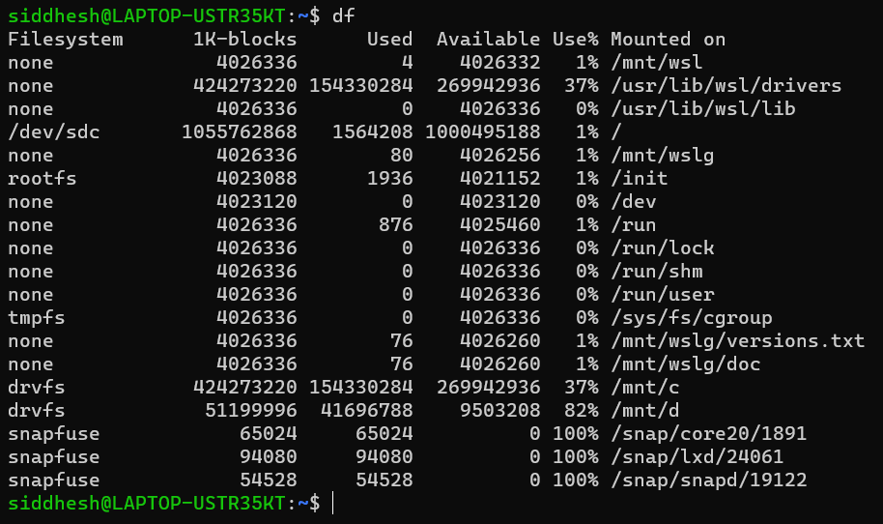

1. type: The type command tells you whether a Linux command is built-in shell command, where is its executable located and whether it is aliased to some other command.

1. clear: The clear command in Linux is used to clear the terminal screen. To use it, simply type clear and press Enter. You can also use the keyboard shortcut Ctrl+L to clear the terminal screen.  
   Here are some examples of how to use the clear command:  
   * clear: Clears the entire terminal screen.  
   * clear -l: Clears the current line of the terminal screen.  
   * clear -n: Clears the next n lines of the terminal screen.  
   The clear command can be used in any Linux environment, including Ubuntu, Fedora, and CentOS.

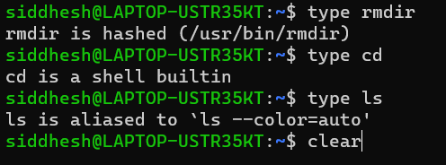

1. id: The id command is a basic Linux command used to confirm the identity of a specified Linux user. It is also used to find user and group names, along with the UID and GID of any user in Linux. By default, the id command is available in all the Linux operating systems.

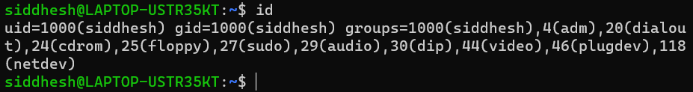

1. passwd: The passwd command changes passwords for user accounts.

Syntax: passwd [options] [LOGIN]

1. groupadd: The groupadd command creates a new group account using the values specified on the command line plus the default values from the system. The new group will be entered into the system files as needed.

1. cut: The cut command in UNIX is a command for cutting out the sections from each line of files and writing the result to standard output. It can be used to cut parts of a line by byte position, character, and field. Basically, the cut command slices a line and extracts the text. It is necessary to specify option with command otherwise it gives error. If more than one file name is provided, then data from each file is not precedes by its file name.

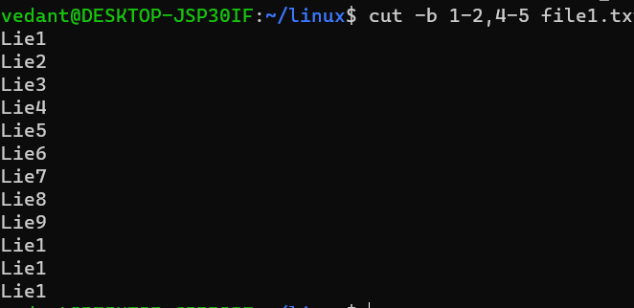

1. tr: The tr command is a UNIX command-line utility for translating or deleting characters. It supports a range of transformations including uppercase to lowercase, squeezing repeating characters, deleting specific characters, and basic find and replace.

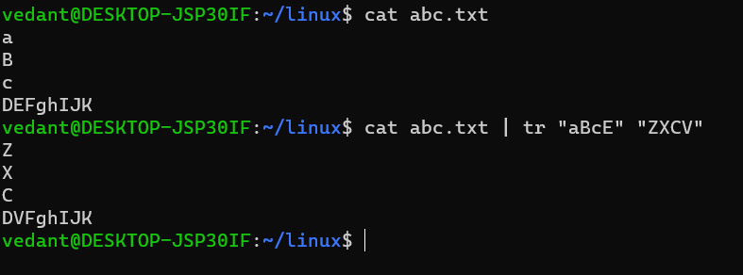

1. wc: The wc command in Linux is a command-line tool that counts the number of lines, words, and bytes in a file. It can also be used to print the length of the longest line in a file. The wc command is a very versatile tool and can be used for a variety of tasks, such as checking the size of a file, counting the number of words in a document, and finding the longest line in a file.

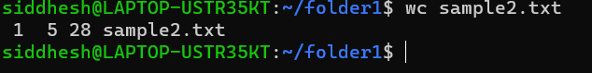

1. od: The od command in Linux is a utility that can be used to display the contents of a file in different formats. The default format is octal, but it can also be displayed in hexadecimal, decimal, and ASCII. The od command is useful for debugging Linux scripts and for visualizing data that is not in a human-readable format.

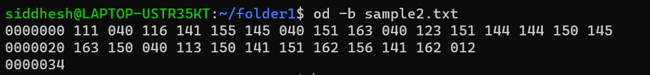

1. du -ah:

1. du -sh:

1. ps:

1. ps -ef:

